Adult Social Services

Monday to Friday, 8am to 6pm except public holidays - 01522 782155

In an emergency including out of hours, this will put you through to the on call duty team – 01522 782333



**Information about care and support in Grantham**

**For St Peter’s Hill Surgery Patients**

Still Struggling?

If you need any further support, please contact the Surgery and asked for the Practice Care Coordinator team to get in contact with you. We will then ring you and arrange a home visit or try to help you over the phone if appropriate.

Lincolnshire Care Directory

For further information please look at:

https://www.carechoices.co.uk/publication/lincolnshire-care-services-directory/

8

Contact Details

St Peters Hill Surgery,

15 St Peter's Hill,

Grantham

NG31 6QA

01476 850123

7

2

**Support and Information Contacts**

Adult Social Care – 01522 782155

Lincolnshire County Council **-** 01522 552222

South Kesteven District Council - 01476 406080

Wellbeing Lincs – 01522 782140

Safe & Well Check (Fire safety) – 01476 565441

Steps 2 Change (Mental health support) – 0303 1234000

Parkinson – 0344 225 9850/ 01476 563056

MS Society – 0808 800 8000

Red Cross – 0300 456 1155

Red Cross First Call - 0345 054 7171

Grantham Blind society – 01476 592775

Citizens Advice – 0344 4111 444

Age UK – 0800 678 1602

British Legion – 0808 802 8080

Dementia UK – 0800 888 6678

Alzheimer’s Society – 0300 222 1122

Marie Curie Rapid response – 0845 055 0709

Macmillan Support –01522 530639

St Barnabas Hospice – 01476 591010/0300 0200 694

Silver Line (Help line for patients who are feeling lonely and anxious, 24hours 7 days a week) – 0800 470 8090

2

7

**About this leaflet**

We have designed this leaflet to give you as much information as possible to allow you to get the right support in place. Whether you are a carer or the individual needing care, this will hopefully help you.

There are a few ways of getting care in place or moving to a care home which depends on your personal situation.

Social Services can be contacted to put emergency respite care in place, as well as look at long term care at home or in a care home. They will assess your financial situation as well as assess your care needs to get the most appropriate care in place.

Respite care can last from 1 – 8 weeks depending on your situation. Please either contact the care home directly if you are self-funding or speak to social services about getting this in place.

If you will be self-funding the care, it will be down to you to contact the care agencies. Please see the contact details for local care homes and care agencies. Each one charge differently, therefore it is important to decide what is best for you. Social Services can assist but they can charge you for this service.

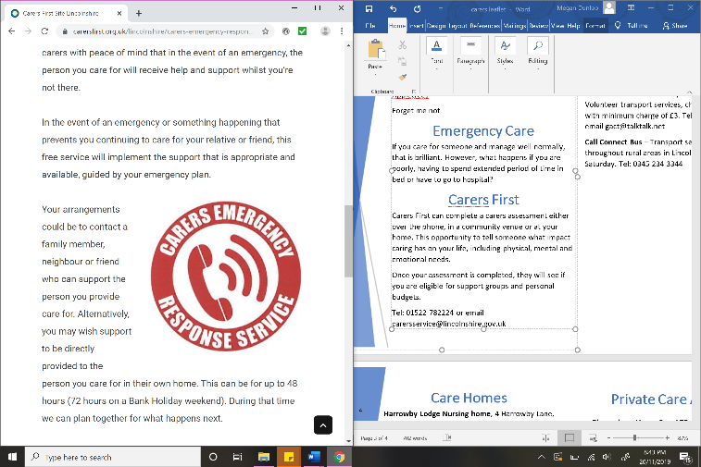

**Emergency Care**

What happens if you as a carer are poorly, having to spend an extended period of time in bed or have to go to hospital? Who will look after them while you get back on your feet?

A Carers Emergency Response Service provides peace of mind that in the event of an emergency, the person you care for will receive help and support. Care can be put in place for the first 48 hours while a plan is put in place for care after this period.

Contact 0300 303 1555 or for more information visit:<https://www.carersfirst.org.uk/lincolnshire/carers-emergency-response-card>

**CarersFirst**

CarersFirst can complete a carer’s assessment either over the phone, in a community venue or at your home. This provides an opportunity to tell someone what impact caring has on your life, including physical, mental and emotional needs.

Once your assessment is completed, they will see if you are eligible for support groups and personal budgets.

Tel: 0300 303 1555 or email hello@carersfirst.org.uk

3

**Day Care and Social Support**

**Spriteleys** Tel: 01529 416270   
or visit [www.asaorg.co.uk](http://www.asaorg.co.uk)

**Gregory House** Tel: 01476 562192

**Apple Trees** Tel: 01476 542700

**Forget me not** Tel: 01476 594533

**Farrow Friends**. Tel: 07960 454632 or email [farrowfriends@outlook.com](mailto:farrowfriends@outlook.com)

**Grantham Men’s Shed**. Tel: 07717 265509

**Other services**

**Adult Supporting Adults** – Provides carers breaks by sitting with your loved one, can take you out shopping and help with personal budgets. Tel: 01529 416270 or visit [www.asaorg.co.uk](http://www.asaorg.co.uk)

**Grantham Area Community Transport (GACT)** – Volunteer transport services, charges 50p per mile with minimum charge of £3. Tel: 01476 978916 or email gact@talktalk.net

**Call Connect Bus** – Transport service operates throughout rural areas in Lincolnshire Monday to Saturday. Tel: 0345 234 3344

6

**Private Care Agencies**

**Under my Wing**. Tel: 07951 281888

**Caring Companions.** Tel: 07452 976226

**Blossoming Hearts.** Tel: 01476 210224

**Bluebird** **Care**. Tel: 01476 859 859

**Charisma Services**. Tel: 01400 279119

**Gilder Care Ltd**. Tel: 01476 978077

**Helping Hand Home Care** Tel: 01476 512394

**Greenwood Home Care** Tel: 01476 849522

**Bloomsbury Home Care Ltd**. Tel: 01476 210224

**Meadows Homecare Services**. Tel: 01476 574353

**Farrow Friends**. Tel: 07960 454632

Please note there may be other care

agencies available not mentioned above.

53

43

4

5

**Care Homes**

**Harrowby Lodge Nursing home**, 4 Harrowby Lane, Grantham, NG31 9HX. Tel: 01476 568505

**Kings Court Nursing home**, Church Lane, Grantham, NG31 6RR. Tel: 01476 576928

**Newton House**, 148 Barrowby Road, Grantham, NG31 8AF. Tel: 01476 452420

**Red Court Community Care**, Worcester Road, Grantham, NG31 8SF. Tel: 01476 576811

**Apple Trees Care and Reablement Centre**, Arlington Gardens, Grantham, NG31 7GQ. Tel: 01476 542700

**Avery Lodge**, 37 Beacon Lane, Grantham, NG31 9DN. Tel: 01476 590674

**Belvoir House Care Home**,Brownlow Street, Grantham, NG31 8BE. Tel: 01476 565454

**Birchwood Retirement Home**, 6-8 Retirement Home, Grantham, NG31 9AA. Tel: 01476 562042

**Castlegate House Retirement Home**, 49 Castlegate, Grantham, NG31 6SN. Tel: 01476 560800

**Gregory House**, Welby Gardens, Grantham, NG31 8BN. Tel: 01476 562192